**1.3 THE *char* TYPE**

The *char* type is used for working **with characters**. A date of this type will represent a single character. To store more characters we will use an **array** with *char* elements or a *string*.

**Variables of type char**

A char variable is declared like this:

e.g.: *char C;*

The value of a *char* (or *signed char*) variable is a natural number between **-128** and **127**. Values ​​between **0** and **127** correspond to characters in the **ASCII code**.

Similarly, *unsigned char* data has values ​​between **0** and **255**. We notice that both types contain the values ​​that correspond to the characters in the **ASCII code**.

**Literals**

A *char literal* (value) is a **character** in the **ASCII code**, delimited by **apostrophe** characters (').

We can initialize a *char* variable by assigning it a **char literal** or a **numeric value**. If the numeric value does not belong to the corresponding value range, it will be **truncated**.

e.g.: *char C;*

*C = 'A';*

*C = 65;*

**Display and reading**

Although *char* data stores integers, reading and displaying them will work **with characters**.

**Display**

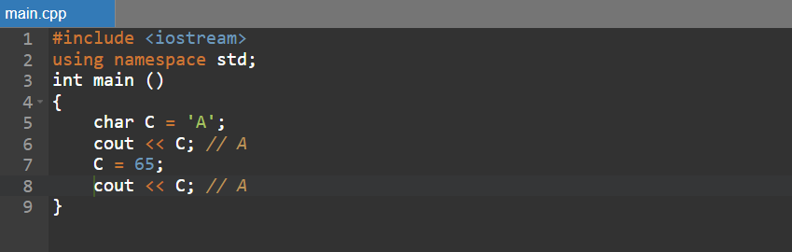

Displaying a char data is done like this:

* if the value is **from ASCII code**, the corresponding character will be displayed. For non-printable characters the effect depends on the character and the working environment (maybe nothing or various symbols are displayed).
* if the value is **outside the ASCII code**, the effect depends on the working environment.

**Reading**

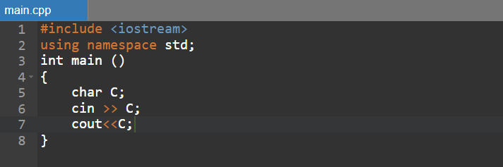

After reading a *char* variable from the keyboard, it will represent the character entered. If more than one character is entered, **only the first character will be read**.

**Examples**

1. 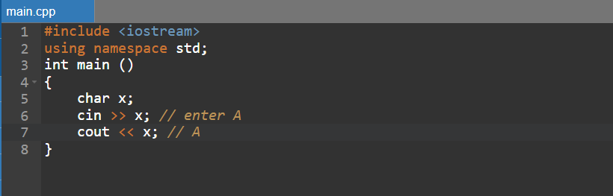
2. 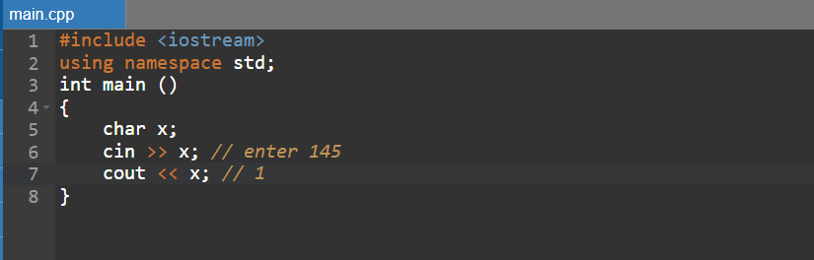
3. 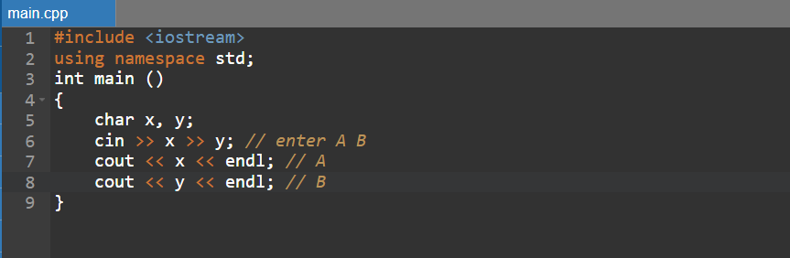
4. 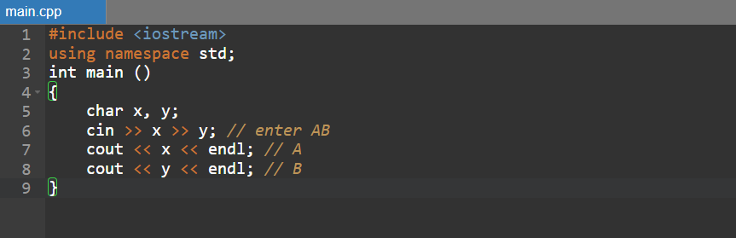
5. 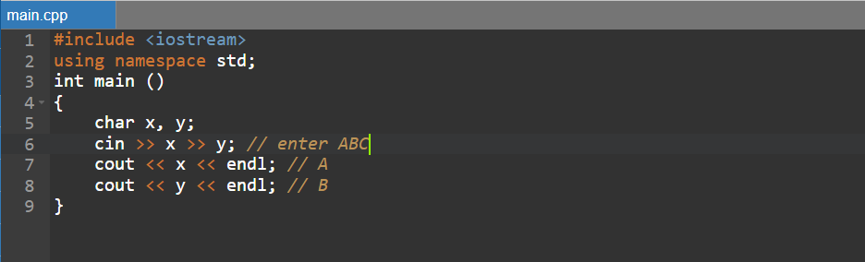
6. 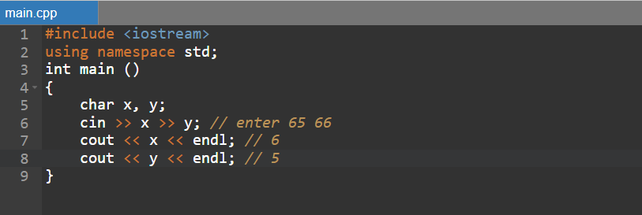

**Operations. Type conversions**

*char* values ​​can be converted to **other** types.

e.g.:

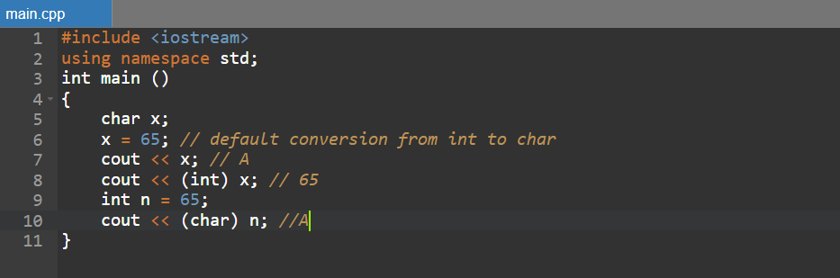

All the usual number operations can be done with *char* data. The *char* value will be converted to *int* by default, **then** the operations will be done.

e.g.:

1. 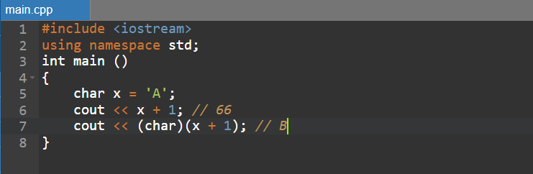
2. 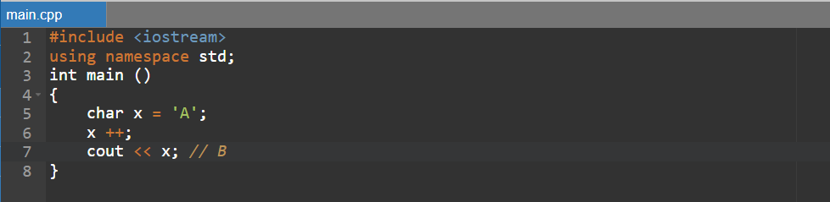

**Convert between upper and lower case**

**A frequent problem** is determining, for an uppercase letter, the corresponding lowercase letter, or vice versa. The solution is based on the fact that in **the ASCII code**, uppercase letters are positioned **before** lowercase ones, and the difference between the ASCII code of a lowercase letter and the ASCII code of the corresponding uppercase letter is the same for all letters (32).

The transformation will be done by **subtracting** this value from the lowercase letter, or by adding it to the uppercase letter.

e.g.:

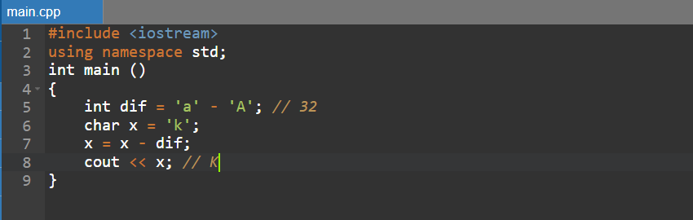

**Pay attention to!**

* “ – quotes delimit strings. A single-character string is not the same as a character.

("A" ≠ 'A'!)